# Inputs Parameters

This is for the “smaller instance” of the problem:

* Planning horizon is decreased from 24 weeks to 10 weeks
* Maximum tracked wait is decreased from 6 weeks to 4 weeks
* There are 3 surgeries instead of 6 surgeries
* Number of priorities is set to 1

Simulation parameters: 30 replications, 3000 weeks duration, 1000 weeks warm up.

Arrival Rate:

It was set to be 93% of the capacity, however due to transitions, the resource usage should be higher than 93%

Surgeries:

* 1. SPINE POSTERIOR DECOMPRESSION/LAMINECTOMY LUMBAR
* 4. SPINE POST CERV DECOMPRESSION AND FUSION W INSTR
* 6. SPINE POSTERIOR DISCECTOMY LUMBAR

|  |  |  |  |  |
| --- | --- | --- | --- | --- |
| **Surgery** | **Complexity** | **Arrival per week -**  **Adjusted to capacity**  **(poisson)** | **Arrival per week –**  **Initial**  **(poisson)** | **Rationale** |
| Surgery 1 | Complexity 1 | 1.21 | 1 | once per week |
| Surgery 1 | Complexity 2 | 0.60 | 0.5 | once per two weeks |
| Surgery 4 | Complexity 1 | 0.14 | 0.083333333 | once per 3 months |
| Surgery 4 | Complexity 2 | 0.10 | 0.0625 | once per 4 months |
| Surgery 6 | Complexity 1 | 1.21 | 1 | once per week |
| Surgery 6 | Complexity 2 | 0.60 | 0.5 | once per 2 weeks |

Usage of the resources:

|  |  |  |  |
| --- | --- | --- | --- |
| **Surgery** | **Complexity** | **Resource type** | **Usage** |
| 1. SPINE POSTERIOR DECOMPRESSION/LAMINECTOMY LUMBAR | Complexity 1 | Admissions | 0 |
| 1. SPINE POSTERIOR DECOMPRESSION/LAMINECTOMY LUMBAR | Complexity 1 | OR_Time | 3 |
| 1. SPINE POSTERIOR DECOMPRESSION/LAMINECTOMY LUMBAR | Complexity 2 | Admissions | 1 |
| 1. SPINE POSTERIOR DECOMPRESSION/LAMINECTOMY LUMBAR | Complexity 2 | OR_Time | 4 |
| 4. SPINE POST CERV DECOMPRESSION AND FUSION W INSTR | Complexity 1 | Admissions | 1 |
| 4. SPINE POST CERV DECOMPRESSION AND FUSION W INSTR | Complexity 1 | OR_Time | 4 |
| 4. SPINE POST CERV DECOMPRESSION AND FUSION W INSTR | Complexity 2 | Admissions | 1 |
| 4. SPINE POST CERV DECOMPRESSION AND FUSION W INSTR | Complexity 2 | OR_Time | 5.5 |
| 6. SPINE POSTERIOR DISCECTOMY LUMBAR | Complexity 1 | Admissions | 0 |
| 6. SPINE POSTERIOR DISCECTOMY LUMBAR | Complexity 1 | OR_Time | 1.5 |
| 6. SPINE POSTERIOR DISCECTOMY LUMBAR | Complexity 2 | Admissions | 0 |
| 6. SPINE POSTERIOR DISCECTOMY LUMBAR | Complexity 2 | OR_Time | 2.5 |

System Capacity:

|  |  |
| --- | --- |
| **Resource** | **Capacity per week** |
| Admissions | 1.5 (patient admissions per week – requiring a bed) |
| OR Time | 11.25 (OR hours per week) |

# Description of the Policy (MDP):

### The policy description is based on the following graph.

This graph shows the benefit of scheduling a patient divided by the resource utilization. If it is above 0, it is better to schedule a patient than to let a patient wait. The highest points on the graph should be scheduled first.

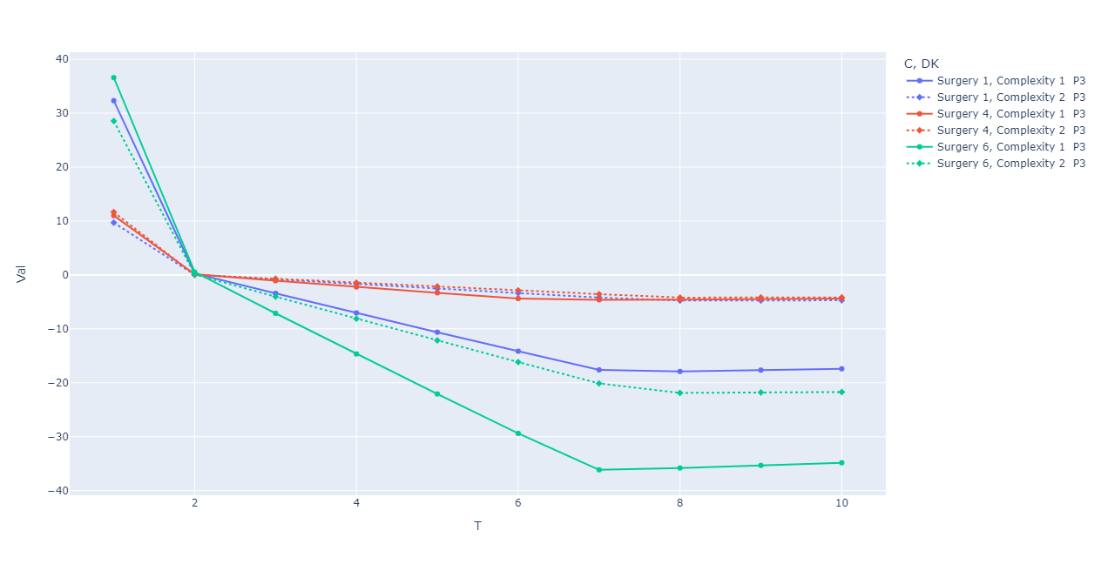

Only the first two weeks will be scheduled into.

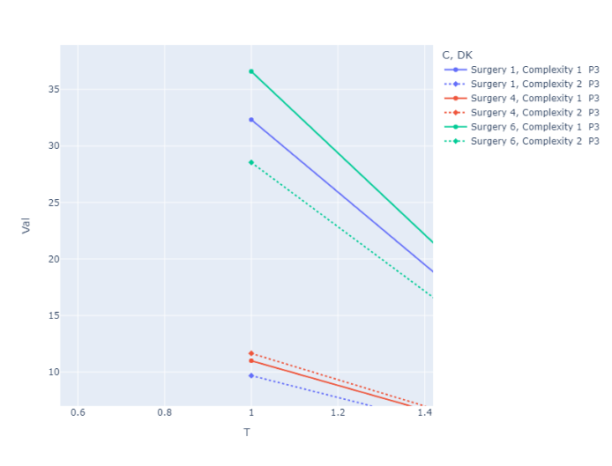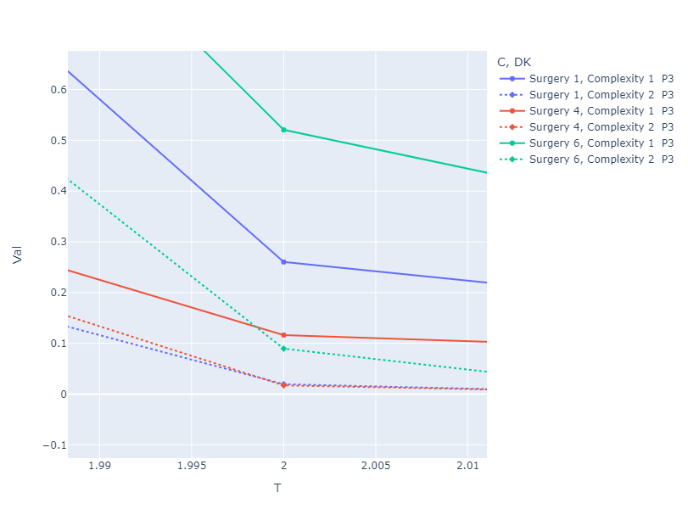

### There are also minor preference towards patients who waited longer (complexity 1 only)

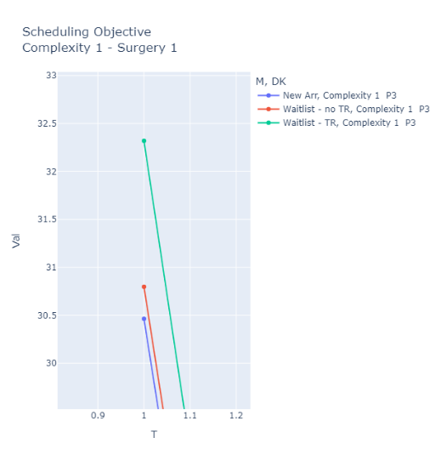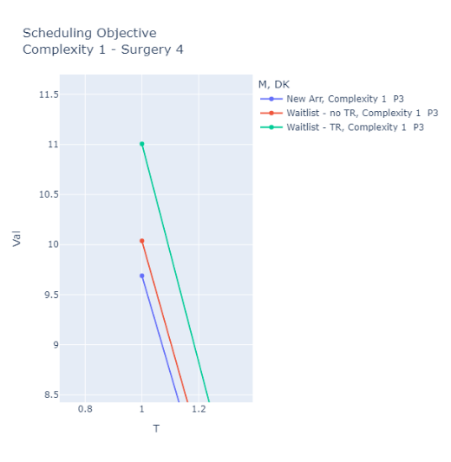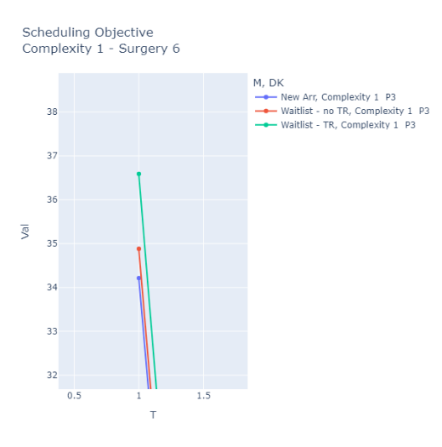

### Description

* This plot shows that the policy would only schedule on week 1 and 2. (For all weeks after it is below 0).
* First the policy would attempt to fill week 1, then it attempts to fill week 2
  + For week 1 the policy attempts to fill the system in approximately the following order:
    - Surgery 6, Complexity 1
    - Surgery 1, Complexity 1
    - Surgery 6, Complexity 2
    - Surgery 4, Complexity 1
    - Surgery 4, Complexity 2
    - Surgery 1, Complexity 2
  + For week 2 the policy attempts to fill the system in approximately the following order:
    - Surgery 6, Complexity 1
    - Surgery 1, Complexity 1
    - Surgery 4, Complexity 1
    - Surgery 6, Complexity 2
    - Surgery 1 Complexity 2 OR Surgery 4 Complexity 2

# Result Tables

Wait Times in weeks (mean +- 95% margin of error):

Surgeries:

* 1. SPINE POSTERIOR DECOMPRESSION/LAMINECTOMY LUMBAR
* 4. SPINE POST CERV DECOMPRESSION AND FUSION W INSTR
* 6. SPINE POSTERIOR DISCECTOMY LUMBAR

|  |  |  |  |  |
| --- | --- | --- | --- | --- |
|  | Overall | Surgery | | |
|  |  | Surgery 1 | Surgery 4 | Surgery 6 |
| MDP | 5.03 +- 7.87 | 8.75 +- 11 | 11.2 +- 6.52 | 0.511 +- 0.212 |
| Myopic | 13.1 +- 14.4 | 24.3 +- 20.3 | 15.3 +- 4.01 | 1.80 +- 0.679 |

Wait List Size in number of patients (mean +- 95% margin of error):

Surgeries:

* 1. SPINE POSTERIOR DECOMPRESSION/LAMINECTOMY LUMBAR
* 4. SPINE POST CERV DECOMPRESSION AND FUSION W INSTR
* 6. SPINE POSTERIOR DISCECTOMY LUMBAR

|  |  |  |  |  |
| --- | --- | --- | --- | --- |
|  | Overall | Surgery | | |
|  |  | Surgery 1 | Surgery 4 | Surgery 6 |
| MDP | 21.0 +- 6.92 | 17.3 +- 6.73 | 2.74 +- 0.447 | 0.927 +- 0.237 |
| Myopic | 54.4 +- 9.39 | 47.4 +- 9.17 | 3.69 +- 0.41 | 3.26 +- 0.368 |

Utilization (mean +- 95% margin of error):

|  |  |  |
| --- | --- | --- |
|  | Admissions | OR Time |
| MDP | 0.575 +- 0.141 | 0.937 +- 0.075 |
| Myopic | 0.64 +- 0.122 | 0.948 +- 0.0693 |

Percentage of patients rescheduled (mean +- 95% margin of error):

|  |  |  |  |  |
| --- | --- | --- | --- | --- |
|  | Overall | Surgery | | |
|  |  | Surgery 1 | Surgery 4 | Surgery 6 |
| MDP | 2.22% +- 0.235 | 3.11% +- 0.383 | 4.22% +- 1.16 | 1.06% +- 0.203 |
| Myopic | 11.7% +- 1.50 | 14.4% +- 1.63 | 59.2% +- 11.8 | 2.63% +- 0.343 |

Percentage of patients transitioned (mean +- 95% margin of error):

* Number of patients whose conditions worsened (complexity only)

|  |  |  |  |  |
| --- | --- | --- | --- | --- |
|  | Overall | Surgery | | |
|  |  | Surgery 1 | Surgery 4 | Surgery 6 |
| MDP | 1.12% +- 0.160 | 0.605% +- 0.143 | 12.9% +- 1.95 | 0.0594% +- 0.0310 |
| Myopic | 7.93% +- 1.30 | 9.56% +- 1.50 | 37.2% +- 7.14 | 2.38% +- 0.428 |

# Some Graphs:

